Assignment - 7.3

Nam: B.Vaishnavi
H.No. : 2303A51657
Batch : 28

Task 1: Fixing Syntax Errors
Buggy Code (Before Debugging):
def add(a, b)
return a + b print(add(3, 5))

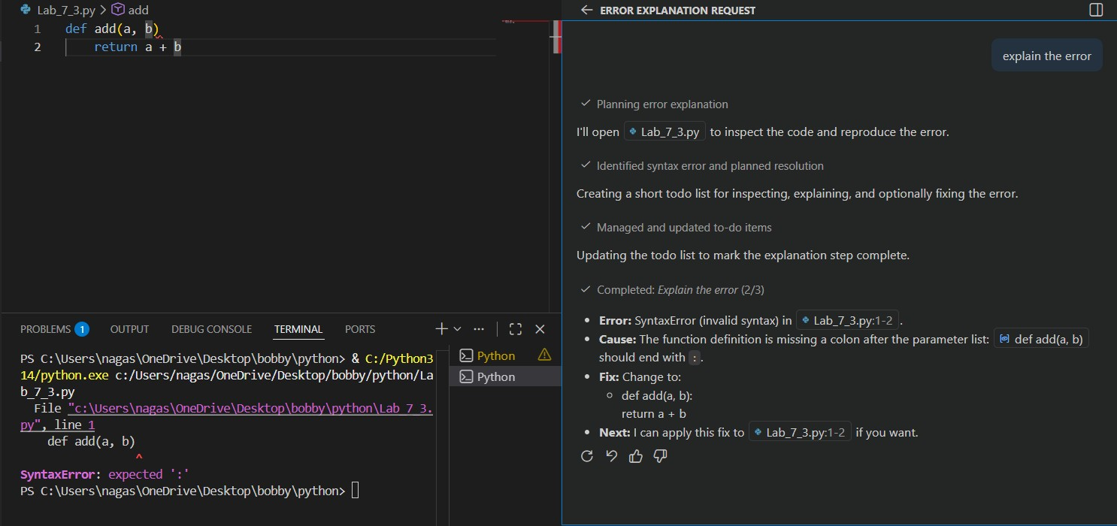

AI-Detected Issue
- Missing colon (:) at the end of the function definition.

- This causes a SyntaxError.

Corrected Code (After Debugging):
def add(a, b):
return a + b
print(add(3, 5))

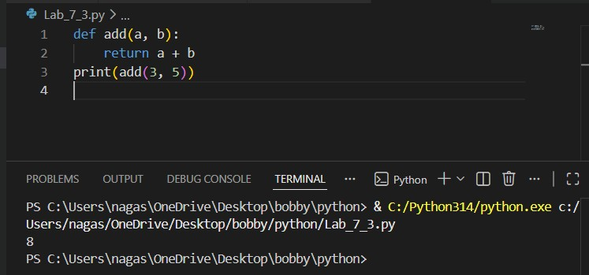

AI Explanation
In Python, every function definition must end with a colon.
The missing colon caused the syntax error. Adding it fixes the issue.

Task 2: Debugging Logic Errors in Loops
Buggy Code (Before Debugging):
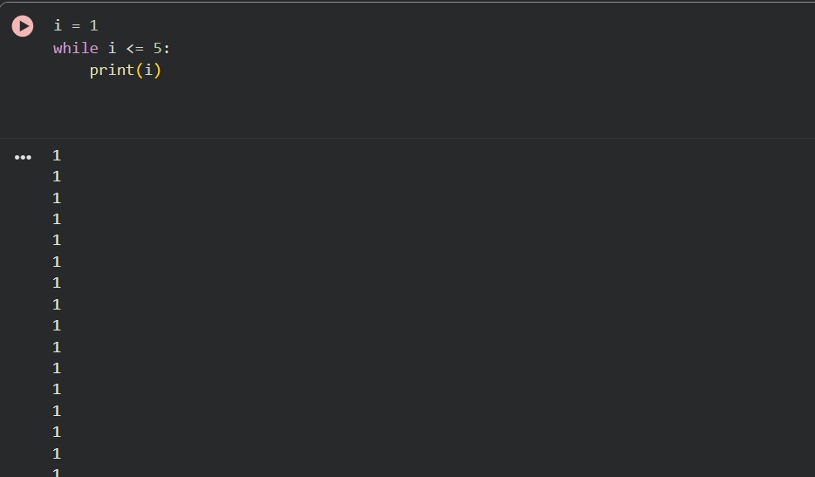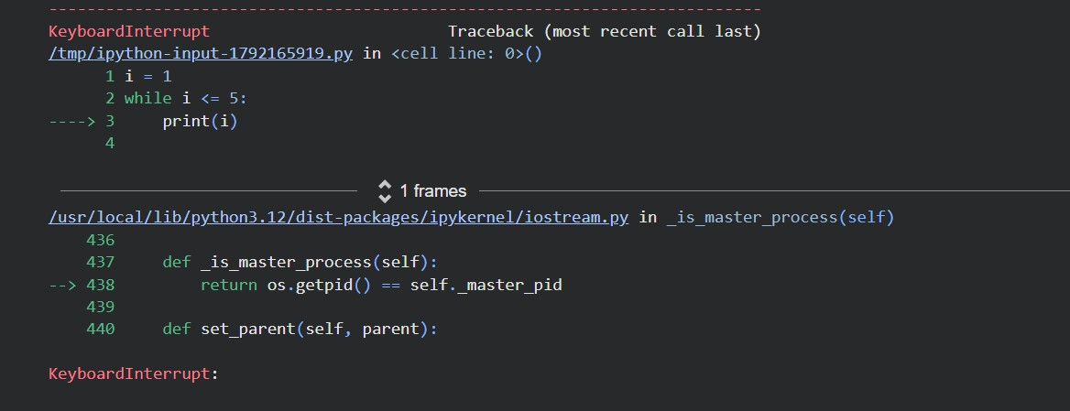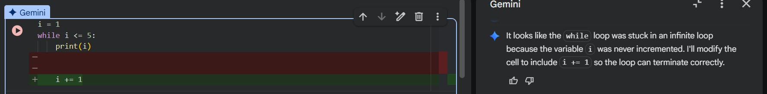

AI-Detected Issue
- The loop variable i is never incremented.

- This causes an infinite loop.

Corrected Code (After Debugging)
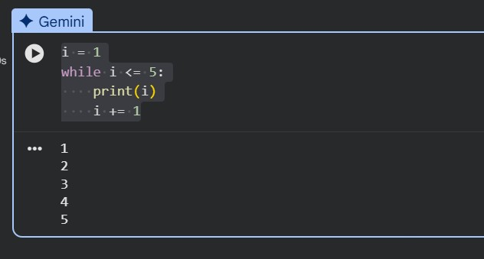
Task 3: Handling Runtime Errors (Division by Zero) Buggy Code (Before Debugging):
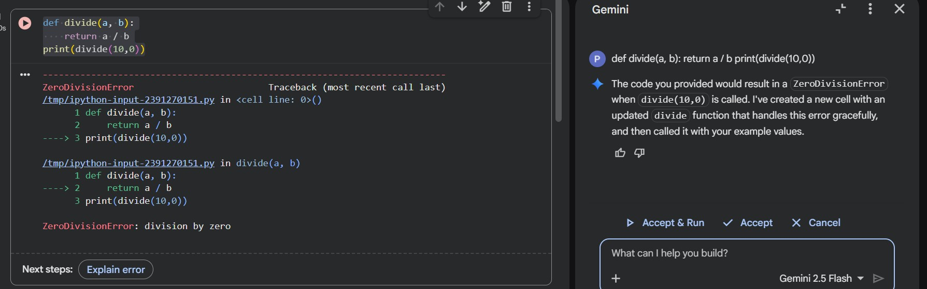

AI-Detected Issue
● If b is zero, the program crashes with ZeroDivisionError.

Corrected Code (After Debugging):
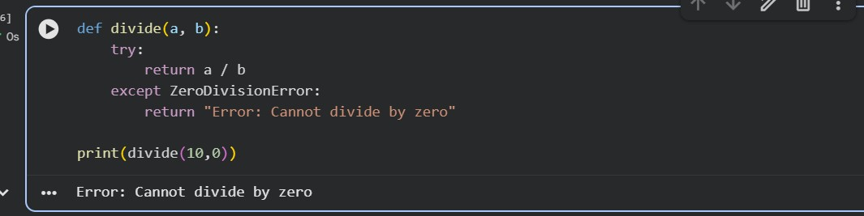

AI Explanation
The AI used a try-except block to handle runtime errors safely.
This prevents the program from crashing.
Task 4: Debugging Class Definition Errors Buggy Code (Before Debugging):
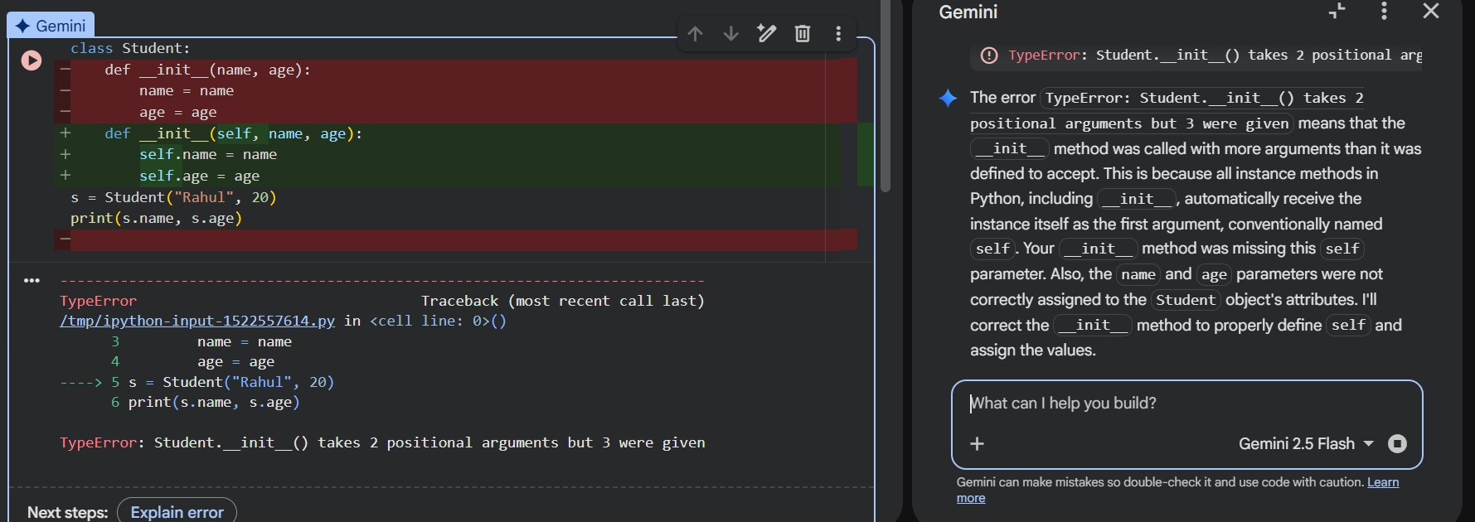

AI-Detected Issue
- Missing self parameter in the constructor.

- Instance variables are not assigned correctly.

Corrected Code (After Debugging):
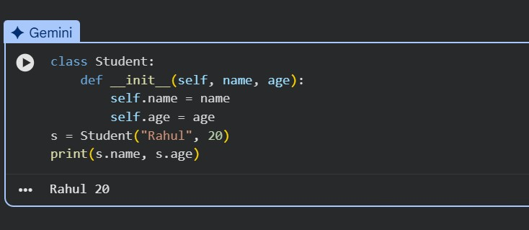
Task 5: Resolving Index Errors in Lists Buggy Code (Before Debugging):
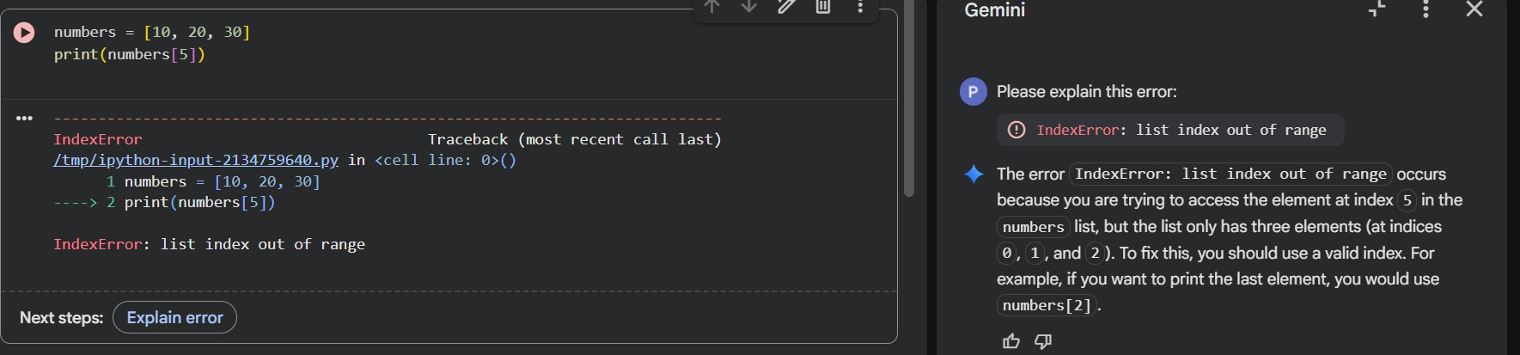

AI-Detected Issue
- Index 5 does not exist in the list.

- Causes an IndexError.

Corrected Code (After Debugging):
